NATIONAL JUNIOR COLLEGE
PRELIMINARY EXAMINATIONS
Higher 2

MATHEMATICS 9740/01 Paper 1 14 September 2012
3 hours
Additional Materials: Answer Paper List of Formulae (MF15) Cover Sheet 0815 – 1115 hours
READ THESE INSTRUCTIONS FIRST
Write your name, registration number, subject tutorial group, on all the work you hand in. Write in dark blue or black pen on both sides of the paper. You may use a soft pencil for diagrams or graphs. Do not use paper clips, highlighters, glue or correction fluid.
Answer all the questions. Give non-exact numerical answers correct to 3 significant figures, or 1 decimal place in the case of angles in degrees, unless a different level of accuracy is specified in the question. You are expected to use a graphic calculator. Unsupported answers from a graphic calculator are allowed unless a question specifically states otherwise. Where unsupported answers from a graphic calculator are not allowed in a question, you are required to present the mathematical steps using mathematical notations and not calculator commands. You are reminded of the need for clear presentation in your answers.
At the end of the examination, fasten all your work securely together. The number of marks is given in the brackets [ ] at the end of each question or part question.
This document consists of 9 printed pages and 2 blank pages.
 National Junior College
1 The diagram shows the graph of 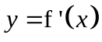, where 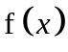 is a cubic polynomial, has a minimum point at (2.5, – 9).
x

0
– 2
7
( 2.5, – 9)

Given that 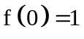, find . [4]
State the range of values of x for which 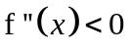. [1]

2 Relative to the origin O, the position vectors of three points, A, B and P are, 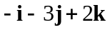, 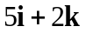 and 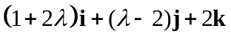, where is a real parameter, 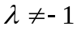.
(i) Show that A, B and P are collinear. [2]
(ii) Find the value of such that P is on the line BA produced and area of triangle OAP is 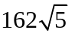 square units. Give a reason for your choice. [4]

3 Use the standard series for 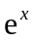 and 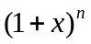 to find the Maclaurin series for 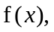 where 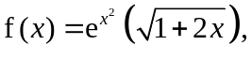 up to and including the term in 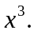 [3]
(a) By substituting 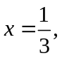 find an approximation for 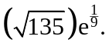 [2]
(b) Find the series for 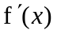 up to and including the term in 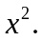 Hence or otherwise, find the Maclaurin series for 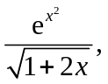 up to and including the term in [3]

4 It is known that a particular type of bacteria grows very well under certain controlled conditions in a specially prepared Petri dish. The researcher believes that the growth rate of such bacteria can be modeled by 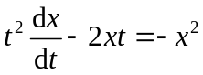, where x milligrams is the amount of bacteria grown in the dish after t hours.
(i) Using the substitution 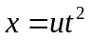, show that the differential equation can be reduced to 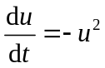. [2]
(ii) Find x in terms of t, given that there was 0.2 milligrams of bacteria after 15 minutes. Hence find the amount of this particular type of bacteria after 4 hours. [4]
(iii) Explain if this mathematical model is a realistic one. [2]

5 A curve C has parametric equations
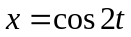, 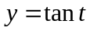, for 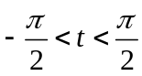.
(i) Sketch the curve C, indicating clearly any asymptotes, and axial intercept(s). [2]
(ii) The point P on the curve has parameter t = 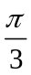. If the normal to the curve at P passes the through the point (b, 0), find the exact value of b. [3]
(iii) Show that the area bounded by the curve C, y-axis and 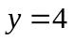, is 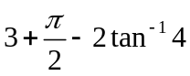. [4]

6 The planes 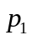 , 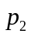 and 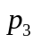 have equations  , 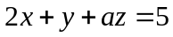 and 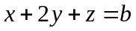, where a and b are real constants. Given that and intersect at the line l, show that the vector equation of l, in terms of a, is
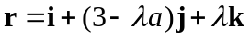, where is a real constant. [2]
(a) The acute angle between l and is 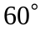. Find the possible values of a. [3]
(b) Given that the shortest distance from origin to is 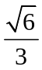 and without solving for the value of b, determine the possible position vectors of the foot of perpendicular from the origin to . [2]
(c) What can be said about a and b if , and do not have any points in common? [4]

7(a) A geometric series has common ratio r, and an arithmetic series has first term a and common difference d, where a and d are non-zero. The first three terms of the geometric series are equal to the ninth, fourth and second terms respectively of the arithmetic series.
- Show that 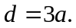 [2]
- Deduce that the geometric series is convergent, and find in terms of a, the sum to infinity. [3]

(b) A mountaineer climbs a mountain of height x metres. The amount of distance he climbs for the first hour is 300 metres. For each subsequent hour, he climbs 10 metres less than the previous hour. The number of whole hours that has passed just before he reaches the summit is n.
- Write down an expression for the total distance climbed by the mountaineer and hence show that 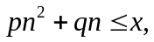 where p and q are constants to be determined. [2]
- Deduce the value of n if 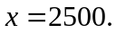 [2]

8 A calculator is not to be used in answering this question.
The polynomial 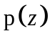 is defined by
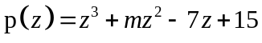,
where m is a real constant. It is given that 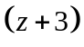 is a factor of , find the value of m. [1]
Given that 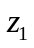, 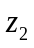and 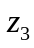 are the roots of the equation = 0, where 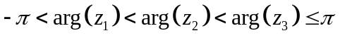,
(i) find , and in exact Cartesian form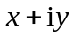where 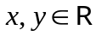. [3]
(ii) show that 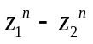 is purely imaginary for 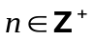. [3]
(iii) explain whether the locus of the complex number w satisfying the equation 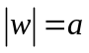, for some positive constant a, passes through all the points representing the complex numbers , 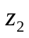 and . [2]

9 A sequence 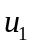, 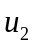, 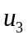, … is such that 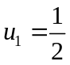 and
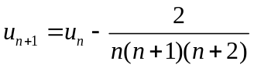, for all positive integers n.
(i) Prove by mathematical induction that 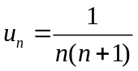. [4]
(ii) Hence, find 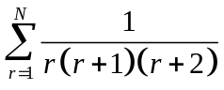. [3]
(iii) Deduce from your results that the series
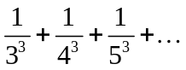
is less than . [2]
(iv) Using the result in (ii), find 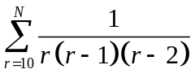, leaving your answer in the form 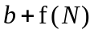 where b is a constant and 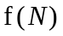 is a function involving N. [3]

10(a) The curve C has equation
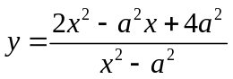, 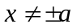,
where a is a positive constant.
(i) Find the equations of the asymptotes, leaving your answers in terms of a. [2]
(ii) Show that if C has two turning points, then 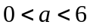. [3]

For 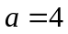, sketch the curve C, stating the equations of any asymptotes, the coordinates of the turning points and axial intercept(s) if any. [2]
Hence, find the range of values of h such that the graph of 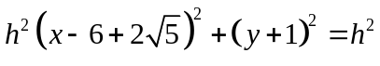,
where h is a positive integer, intersects C more than once. [2]

(b) The diagram shows the graph of 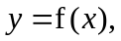which has turning points at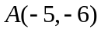and 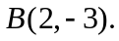The horizontal and vertical asymptotes are y = 0 and x =3 respectively.
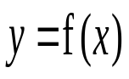
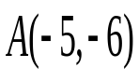
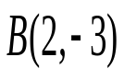
Sketch the graph of 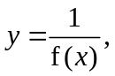 showing clearly all relevant asymptotes, axial intercepts and turning point(s), where possible. [3]
y
O
x
x =
3
1
2

11 The functions f, g and h are defined by
f : x x − 2x² + 1, , < x < 3,
g : x ln(1−2x), , k < x < ,
h : x 18|x − 2| − 18, .
(i) Sketch, on the same diagram, the graphs of f , f ⁻¹ and f ⁻¹f, showing clearly the relationship between the graphs and indicating the axial intercepts. Find the exact value of x for which f ²(x) = x. [5]
(ii) Find the minimum value of k such that f ⁻¹ g exists. [2]
(iii) Using a non-graphical approach, find the set of exact values of x for which
f(x) < h(x). [4]

End of Paper
READ THESE INSTRUCTIONS FIRST

Write your name and CT class on all the work you hand in.
Write your calculator’s model number(s) in the box below.
Write in dark blue or black pen on both sides of the writing paper.
You may use a soft pencil for any diagrams or graphs.
Do not use staples, paper clips, highlighters, glue or correction fluid.

Answer all the questions.
Begin each answer on a fresh page of paper.

Give non-exact numerical answers correct to 3 significant figures, or 1 decimal place in the case of angles in degrees, unless a different level of accuracy is specified in the question.
You are expected to use a graphing calculator.
Unsupported answers from a graphing calculator are allowed unless a question specifically states otherwise.
Where unsupported answers from a graphing calculator are not allowed in a question, you are required to present the mathematical steps using mathematical notations and not calculator commands.
You are reminded of the need for clear presentation in your answers.

At the end of the examination, fasten all your work securely together.
The number of marks is given in brackets [ ] at the end of each question or part question.

Scientific Calculator Model:

Graphing Calculator Model:

For office use
This document consists of 6 printed pages.

NATIONAL JUNIOR COLLEGE
Preliminary Examinations
Higher 2
MATHEMATICS 9740/01 Higher 2 Paper 1
14 September 2012, Friday 0815 – 1115 hours
Candidate Name: ______________________ Registration No.:_____________
Question No. | Marks Obtained | TOTAL MARKS
1 |  | 5
2 |  | 6
3 |  | 8
4 |  | 8
5 |  | 9
6 |  | 11
7 |  | 9
8 |  | 9
9 |  | 12
10 |  | 12
11 |  | 11
Presentation | – 1 / –2
TOTAL |  | 100
GRADE
Subject Class: 2ma______/ 2IPma2_______ Subject Tutor: _______________
For office use

over Page
INSTRUCTIONS TO CANDIDATES
Write your name, registration number, subject tutorial group, subject tutor’s name and calculator model in the spaces provided on the cover sheet and attached it on top of your answer paper.
Circle the questions you have attempted and arrange your answers in NUMERICAL ORDER.
Write your calculator’s model number(s) in the box below.

Scientific Calculator Model:

Graphic Calculator Model:

